**DAILY ONLINE ACTIVITIES SUMMARY**

|  |  |  |  |  |  |  |  |  |
| --- | --- | --- | --- | --- | --- | --- | --- | --- |
| **Date:** | **14-06-2020** | | | | | **Name:** | **SRILATHA K KAMATH** | |
| **Sem & Sec** | **6 B** | | | | | **USN:** | **4AL17CS099** | |
| **Online Test Summary** | | | | | | | | |
| **Subject** | | **-** | | | | | | |
| **Max. Marks** | | **-** | | **Score** | | | **-** | |
| **Certification Course Summary** | | | | | | | | |
| **Course** | **Introduction to cloud** | | | | | | | |
| **Certificate Provider** | | | **IBM** | | **Duration** | | | **5 hours** |
| **Coding Challenges** | | | | | | | | |
| **Problem Statement:** Python program to find the length of a string without using library function. C program to find the binary reversal of a number. | | | | | | | | |
| **Status: COMPLETED** | | | | | | | | |
| **Uploaded the report in Github** | | | | | **YES** | | | |
| **If yes Repository name** | | | | | https://github.com/alvas-education-foundation/Srilatha-K-Kamath-Daily-Report.git | | | |
| **Uploaded the report in slack** | | | | | **YES** | | | |

Online Test Details: -

Online Course Details: Completed the course “Introduction to Cloud”. Obtained the badge and certificate. Uploaded both in Github.

Badge:

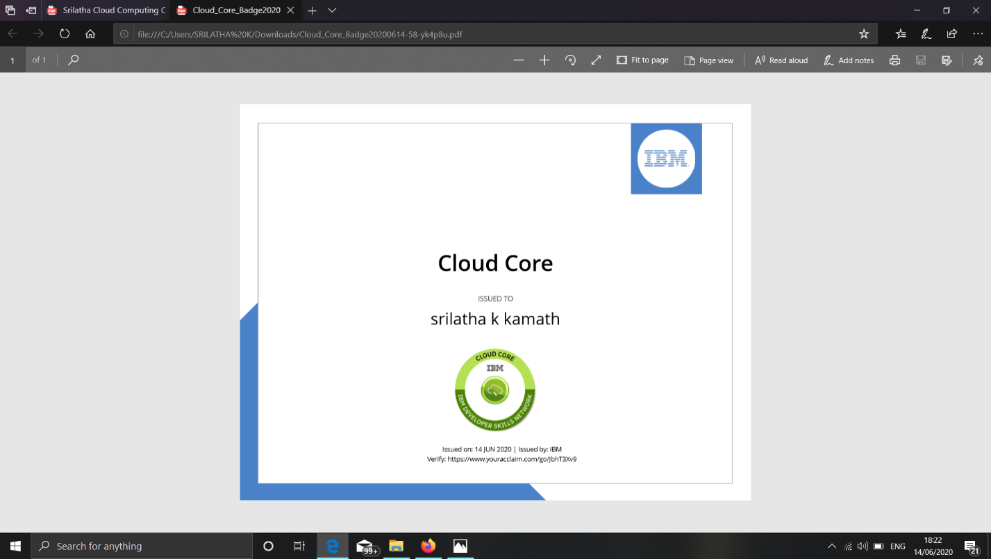

Certificate:

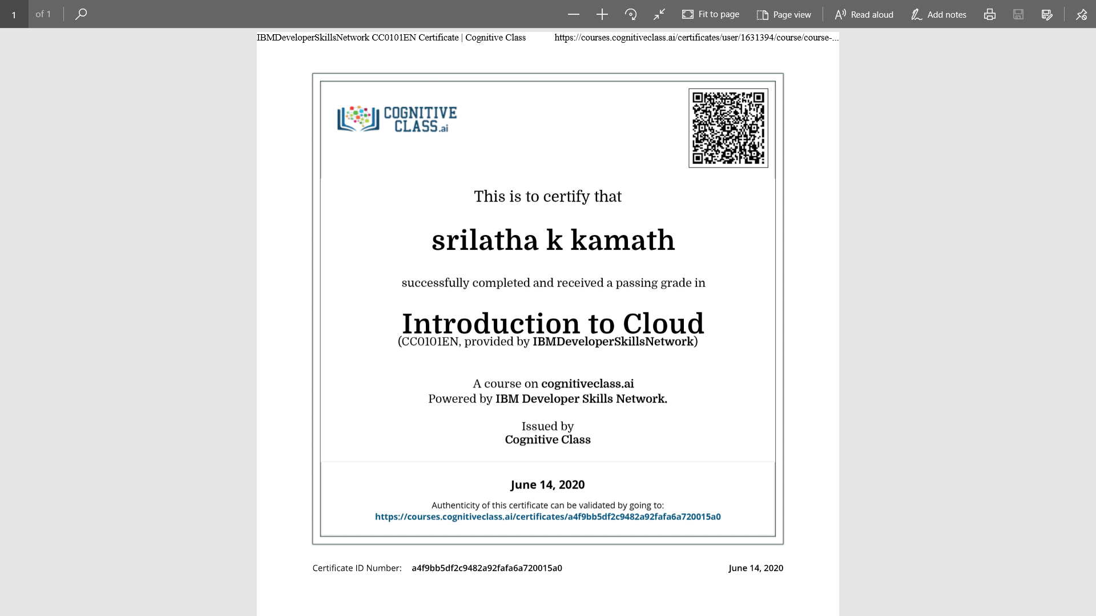

Online Coding Details:

1. Python program to find the length of a string without using library function.

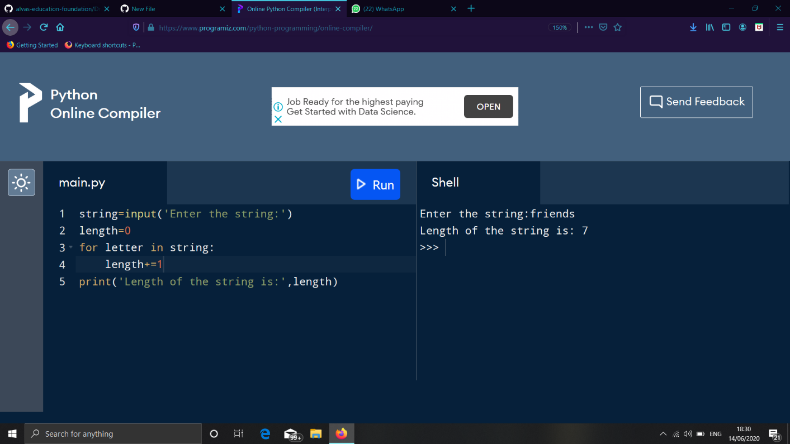

2. C program to find the binary reversal of a number.